IZMIR INSTITUTE OF TECHNOLOGY

DEPARTMENT OF ELECTRICAL AND ELECTRONICS ENGINEERING

EE 210 MIDTERM – SPRING 2015 APRIL 1st 2015

Instructor: Cenk Efeler

1. The voltage and current across a circuit element vary according to the relationships given below:

 V   <0

 A   <0

1. Find the instantaneous power function and sketch it for two periods. (10 Points)
2. Using the sketch, state the times at which the power is maximum and the times at which it is minimum and determine the maximum and minimum values of the power within two periods. (5 Points)
3. Calculate the average power for  (10 Points)

2- For the circuit shown

1. Compute the total power delivered to the circuit. (15 Points)
2. Compute the total power absorbed by the circuit. (10 Points)

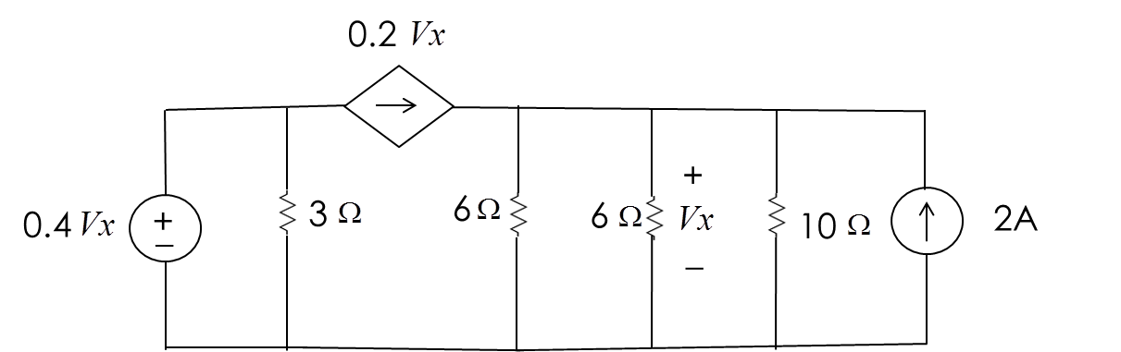

3-

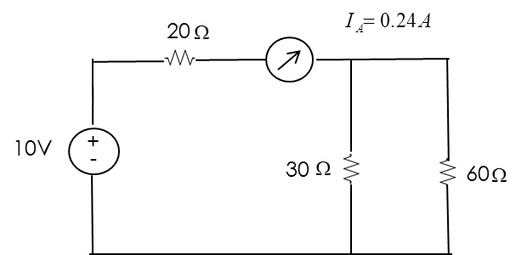

a) What is the percentage error in the ampermeter reading ? (5 Points)

b ) Find the value of the internal resistance of the ampermeter. (5 Points)

1. Find the value of the internal resistance of a second ampermeter that needs to be connected to the circuit in order to reduce the measurement error of the first ampermeter to 1 %. (15 Points)

4-

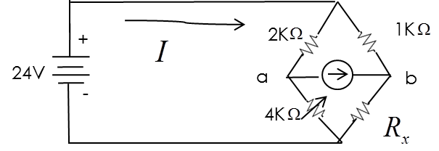

1. Using Kirchoff’s laws, find the value of resistance Rx of the balanced wheatstone bridge shown. (Do not use the formula directly). (10 Points)
2. Using the value of Rx found in a), calculate the internal resistance of the ampermeter. (15 Points)